

**SSR COLLEGE OF ARTS, COMMERCE & SCIENCE**

***(Affiliated to Savitribai Phule Pune University)***

**Submitted to the partial fulfilment of**

**T.Y.BSc(Comp. Sci)**

**2019-2020**

**PROJECT WORK**

**SMART CLEAN**

**Guided by: Submitted by:**

**Mrs. Kavita Saptasagar 1. Mahesh S. Bhadane**



**SSR COLLEGE OF ARTS, COMMERCE & SCIENCE**

**(Affiliated to Savitribai Phule Pune University)**

**Sayli, Silvassa – 396230, D & N.H.**

***Department of Computer Science***

**C E R T I F I C A T E**

This is to certify that Mr. MAHESH SHANTARAM BHADANE

of T.Y.BSc(Comp.Sci) Seat No. has completed his project work on the topic “SMART CLEAN” during the year 2019 – 2020.

Project Guide H.O.D.

Internal Examiner External Examiner

Seal of the College

**ACKNOWLEDGEMENT**

It is a great pleasure to acknowledge and express my deep sense of gratitude to **SSR COLLEGE OF ARTS, COMMERCE & SCIENCE** for providing me the infrastructure to carry out the project.

I extremely grateful and remain indebted to my guide **Mrs. Kavita Saptagar** for being a source of inspiration and for her constant support in the Design, Implementation and Evaluation of the project. I thankful to her for their constant constructive criticism and invaluable suggestions, which benefited me a lot while developing the project on **SMART CLEAN**. She has been a constant source of inspiration and motivation for hard work. She has been very co-operative throughout this project work. Through this column, it would be my utmost pleasure to express my warm thanks to her for her encouragement, co-operative and concern without which I might not be able to accomplish this project.

I also thank to all staff members of my college who were directly and indirectly helpful in enabling me to stay committed for the project.

Project Associate:

Mahesh S. Bhadane

**PREFACE**

This project of **SMART CLEAN** is very simple and useful software. It helps to perform operations like Save, Update, Delete, Clear and Search on Forms in the software.

Concerning the need of Digital involvement in daily practices we dreamt if it is possible to develop such project which gives step ahead to bio converters. So, we decided to design this Digital technique, that can be transformed into waste management system via registering in Computational database system to users and providing smart setups to waste-collectors (Collection Trucks). Considering the efficiency factors, we will provide Location-based waste collection services on request of all the areas on daily basis.

After Collecting waste from all the areas without using worms and other method we find new method called **"Harmetia Sanitizing Bioconverter"** which produce Black Soldier Fly Larvae. Basically, this model is useful for Establishing & Building larvae colonies. The Black Solider Flies to lay eggs in small holes over the grub bin. The BSF holes much promise for converting low-value manures & many other organic “Wastes” into a valuable commodity. In this way amount of waste products or garbage is reduced.

Also, this software provide Graphical user interface that make you use this software with ease, this help user to do their work in less time, and with great efficiency.

|  |  |  |
| --- | --- | --- |
| **TABLE OF CONTENTS** | | |
| **Sr. No.** | **Contents** | **Page No.** |
| **1.Introduction** | | |
| 1.1 | Abstract | 6 |
| 1.2 | Existing System and Its Limitation | 7 |
| 1.3 | Need of Proposed System | 7 |
| 1.4 | Intended Audience | 7 |
| **2.Proposed System** | | |
| 2.1 | Problem Statement | 8 |
| 2.2 | Assumptions and Dependencies | 8 |
| 2.3 | Objectives of proposed System | 9 |
| 2.4 | Module Specification | 9 |
| 2.5 | Operating Environment | 10 |
| **3.Requirement Analysis** | | |
| 3.1 | Fact Finding Methods | 11 |
| 3.2 | Feasibility Study | 11 |
| **4.System Design** | | |
| 4.1 | Use-Case Diagram | 12 |
| 4.2 | Data Flow Diagram | 13 |
| 4.3 | Data Dictionary |  |
| 4.4 | UI Snapshot | 14 |
| **5.Others** | | |
| 5.1 | Drawbacks and limitation of Proposed System | 22 |
| 5.2 | Proposed Enhancements | 22 |
| 5.3 | Conclusion | 22 |
| 5.4 | Bibliography | 22 |

**SMART CLEAN**

1. **INTRODUCTION**
   1. **ABSTRACT**

The SMART CLEAN is a unique digital technique, which can be able to boost the waste-management practices of urban areas in cost-effective and commercial way and able to transform the system into a public integrated one.

The existing system can be transforming to management system via installing computational database system in quantized manner and providing smartphone setups to waste collectors.

Considering efficiency factors, we will provide location-based waste collectors information on the request of enterprises as they produce wastes on daily basis.

In this system when the waste collection bins are full, user will login into the SMART CLEAN website and fill the waste record form then the admin panel will provide the location-based waste collector contact details via which uses can contact to the waste collector and then waste collector can collect the waste.

This system comes with ability to monitor the real time data and status of waste collection for next to this we recycle the waste as we prepare concept of composed, we will calculate effective maximum cost of municipal waste management through all the systems.

This system Save, Delete, Search, Updates all the details like User Details, Enterprises Details, Waste-Collector Details, Waste Records etc.

* 1. **EXISTING SYSTEM AND ITS LIMITATIONS**

Currently there aren’t many online waste management websites due to which user’s face various problems. The existing system is manual system. When over dustbins are get full or overflow of waste then we put all waste into open land feels so many problems created from their. And when waste collectors come home then only he get waste but not get the solution of for that.

**LIMITATIONS:**

1. Present system is hard to know information about waste collectors that they are present or not
2. It is a time consuming while searching of waste without having information of waste.
   1. **NEED OF PROPOSED SYSTEM**

Nowadays, we use smartphones so it is easy to send message via login to our website and using this information we easily manage the waste problems.

Using this system, we will get easily contact of waste collectors from which we send a message to the waste collector of our area.

This system is developing a cost effective and public integrated technique to monitor collection service and ensure proper location information and hence it encourages taking up the system design.

* 1. **INTENDED AUDIENCE**

1. Admin.
2. User.
3. Waste-collector.
4. **PROPOSED SYSTEM**
   1. **PROBLEM STATEMENT**

The problem with some of the current system is that it is manual systems. When over dustbin are get full or overflow of waste then we put all waste into open landfills so many problems created from there, this is a limitation of a system and also the waste collectors cannot collect the waste at the same time from many areas, so it is the major problem for the current system. To solve this problem, we make the new system in which the users can login with our website and Using this system we will get easily contact of waste collectors from which we send a message to the waste collector of our area. This system is developing a cost effective and public integrated technique.

**2.2 ASSUMPTIONS & DEPENDENCIES**

1. The user is using the application without any otherwise intentions.

2. The user of the site is aware of English language.

3. The user has a valid address in order to register to the website.

4. The user has a smartphone or PC or laptop with good internet connections.

5. Browser is required for accessing the website.

6. The user should have a good internet connection.

7. The user should fill the waste record form, from which he gets the contact details of waste collector near to him.

**2.3** **OBJECTIVES OF PROPOSED SYSTEM**

1. To provide information regarding available waste collectors.

2. To design a web-based system that allows users to register and fill the waste record forms and for the waste collectors to effectively manage their waste database.

3. To easy uses task whenever they need to contact waste collectors for collect their waste.

4. Manage details of waste records waste types waste weight collection area waste collector details user details etc.

5. Facility has been provided to admin for users to add new waste collectors & new area details, delete/ update previous records of waste collectors / waste types.

**2.4 MODULE SPECIFICATION**

* **Registration module -** In this module the users will have to register to the website in order to eligible to make waste collection request.
* **Login module –** User once register can then login to the website and access the available waste collectors and make their request for collecting the waste.
* **Request module -** This module will allow to users to request a waste collector according to their requirements for their near to them.
* **Change password module (admin) -** In this module the admin/user can change the password as when needed.
* **Forgot password module -** In this module the users can re-change the password if forgotten.

**2.5 OPERATING ENVIRONMENT**

**2.5.1 HARDWARE REQUIREMENT**

* Processor: Core2Duo Or Higher (1 GHz Or higher)
* Memory: 1GB
* Free disk space: 1GB

**2.5.2 SOFTWARE REQUIREMENTS**

* Platform: Windows, Linux, Mac OS etc.

* Software: Any compactible browser (Ex. Google Chrome, etc.)

**2.5.3 TECHNOLOGIES USED**

* Front-end: HTML, PHP, CSS and JavaScript.

* Back-end: MY SQL.

* Editor: WordPress 5.3, Sublime text 3.

* Platform: Windows OS

* Server: WordPress 5.3, Apache Wamp

1. **REQUIREMENT ANALYSIS**
   1. **FACT FINDING METHODS**

*Background reading.

*Interviews.

*Questionnaires.

*Surveys.

*Research & site visiting.

**3.2 FEASIBILITY STUDY**

**OPERATIONAL FEASIBILITY:**

The customer is benefited more as most of his time is saved and also the environment problems or waste manage problems are gates solve. He does not have to find waste collector or find place to dump waste. He could simply log in to his account on our website and send message to his nearby waste collectors.

**TECHNICAL FEASIBILITY:**

This system does not require high and Hardware or software to use it can be easily accessible from normal machine with less headache.

**ECONOMICAL FEASIBILITY:**

This system is feasible or cost-effective all features included in the system are cost beneficial.

1. **SYSTEM DESIGN**
   1. **USECASE DIAGRAM**

ADMIN

USER

WASTE-

COLLECTOR

* 1. **DATA FLOW DIAGRAM**

**USER ADMIN WASTE-COLLECTOR**

User Register

User Login

Login Successfully

Check Email

Send Confirmation

Fill Waste form

View form

Send Collector Detail

Check Waste-Collection Request

Send Request

Collect Waste

Give Feedback

Give Confirmation

Record Details

* 1. **DATA DICTIONARY**

1. **User Table**

|  |  |  |  |
| --- | --- | --- | --- |
| **Field** | **Type** | **Null** | **Key** |
| ID | bigint(20) unsigned | NO | PRI |
| user_login | varchar(60) | NO | MUL |
| user_pass | varchar(255) | NO |  |
| user_nicename | varchar(50) | NO | MUL |
| user_email | varchar(100) | NO | MUL |
| user_url | varchar(100) | NO |  |
| user_registered | Datetime | NO |  |
| user_activation_key | varchar(255) | NO |  |
| user_status | int(11) | NO |  |
| display_name | varchar(250) | NO |  |

1. **Comment Table**

|  |  |  |  |
| --- | --- | --- | --- |
| **Field** | **Type** | **Null** | **Key** |
| comment_ID | bigint(20) unsigned | NO | PRI |
| comment_post_ID | bigint(20) unsigned | NO | MUL |
| comment_author_email | varchar(100) | NO | MUL |
| comment_date | datetime | NO |  |
| comment_date_gmt | datetime | NO | MUL |
| comment_content | text | NO |  |
| comment_karma | int(11) | NO |  |
| comment_approved | varchar(20) | NO | MUL |
| comment_type | varchar(20) | NO | MUL |
| comment_parent | bigint(20) unsigned | NO | MUL |
| user_id | bigint(20) unsigned | NO |  |

* 1. **UI SNAPSHOT**

1. **Home page**

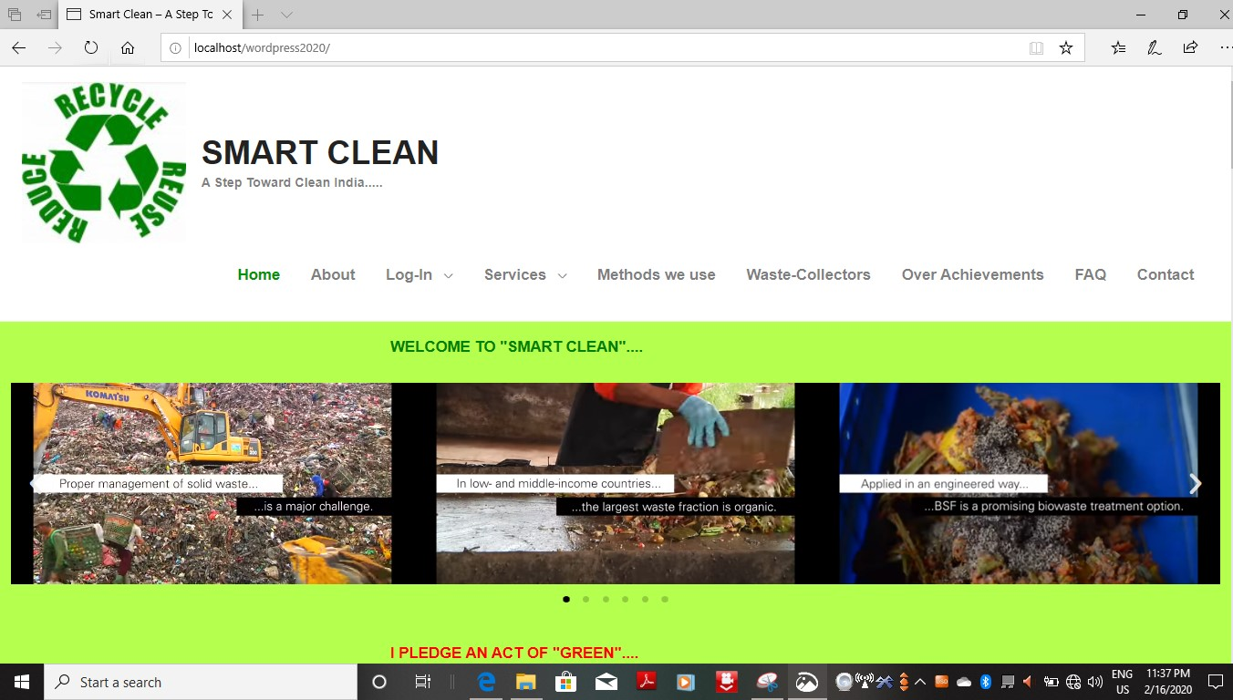

1. 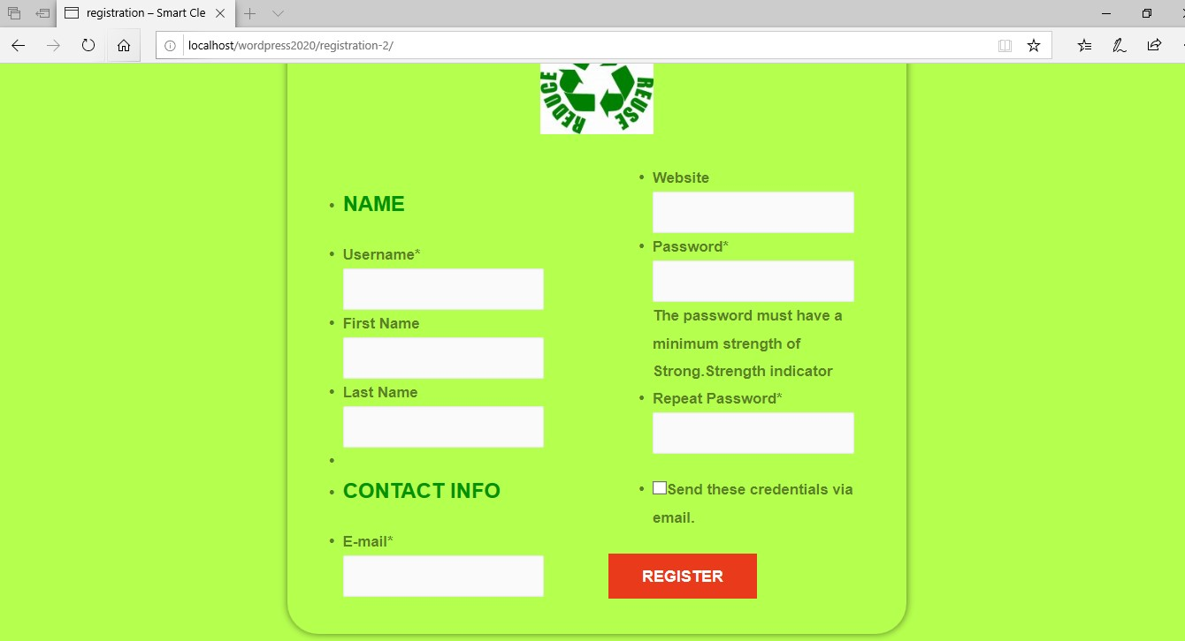**Registration page**
2. 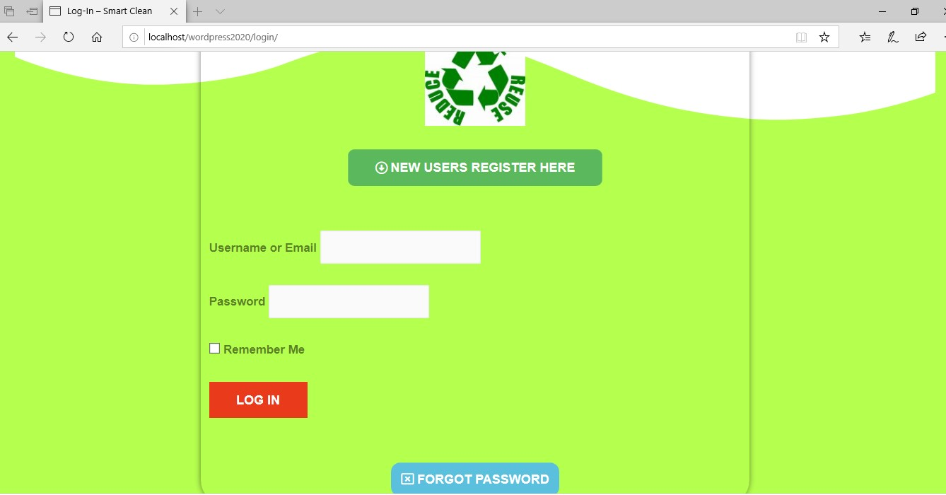**Login page**
3. 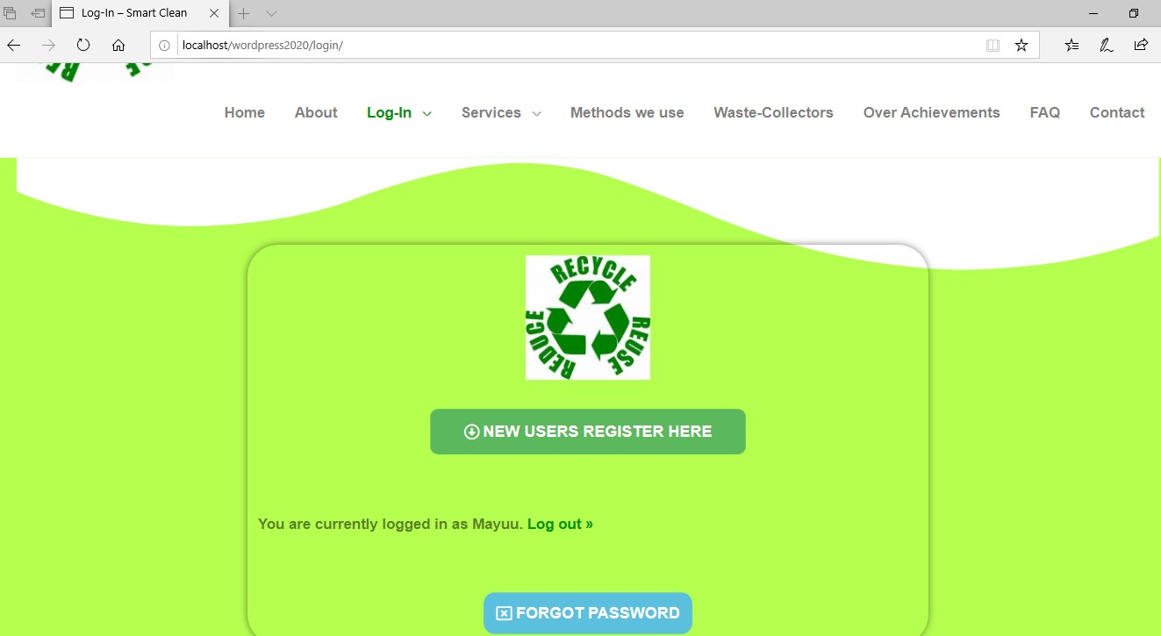**After Logged in page**
4. 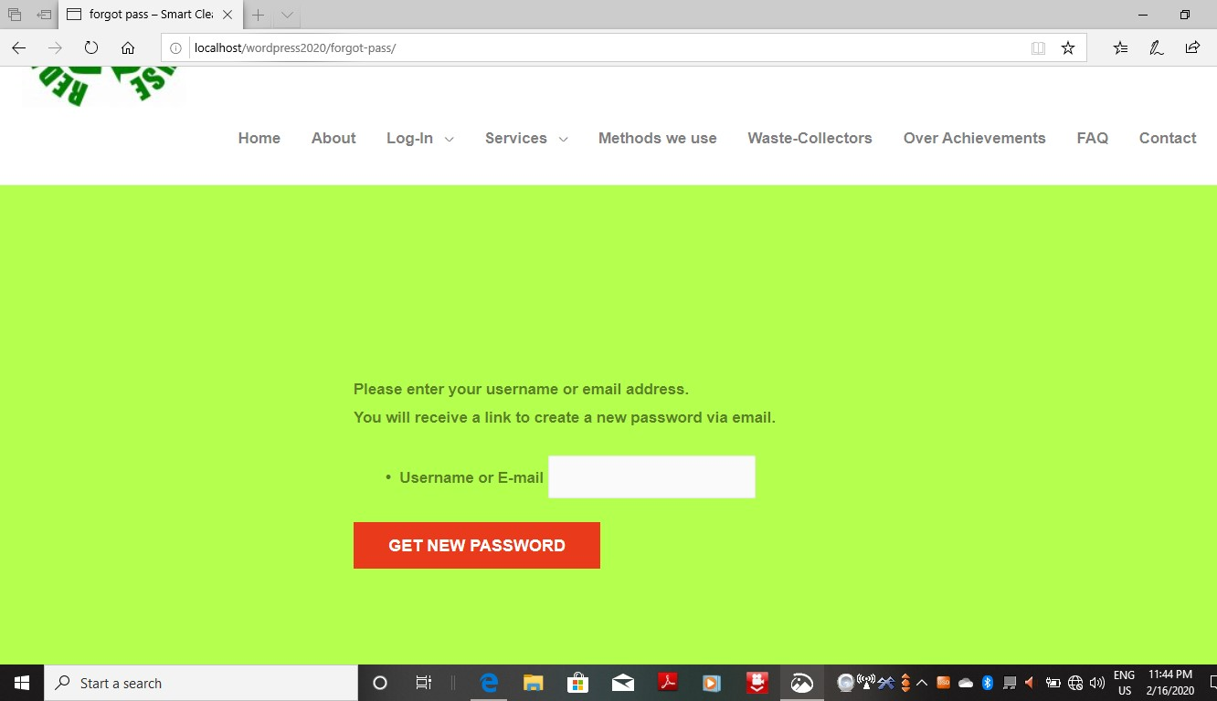**Password recovery page**
5. 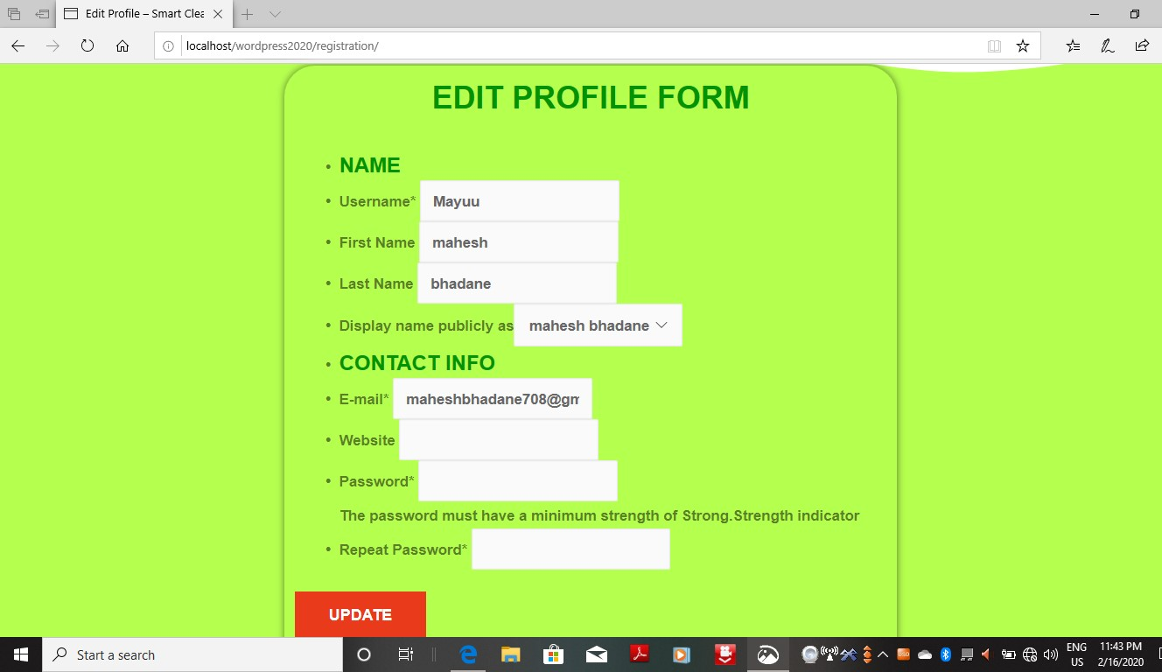**Edit profile page**
6. 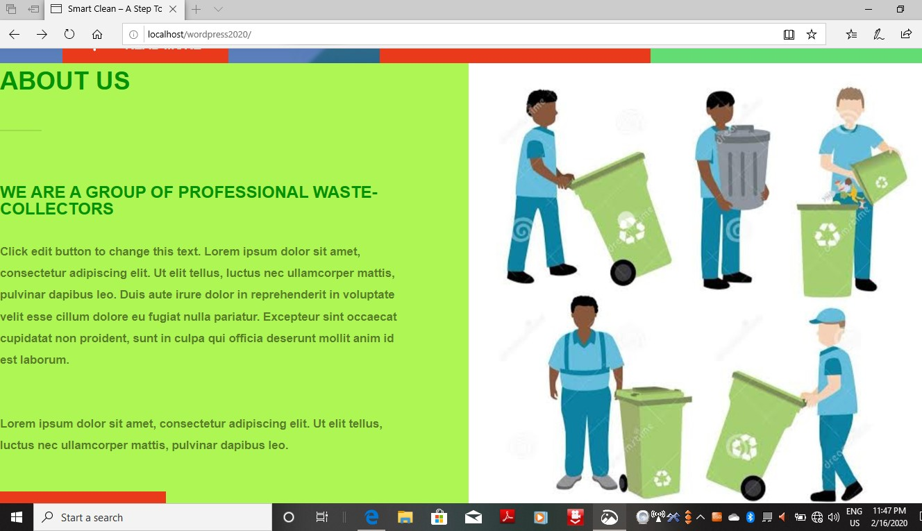**About us page**
7. 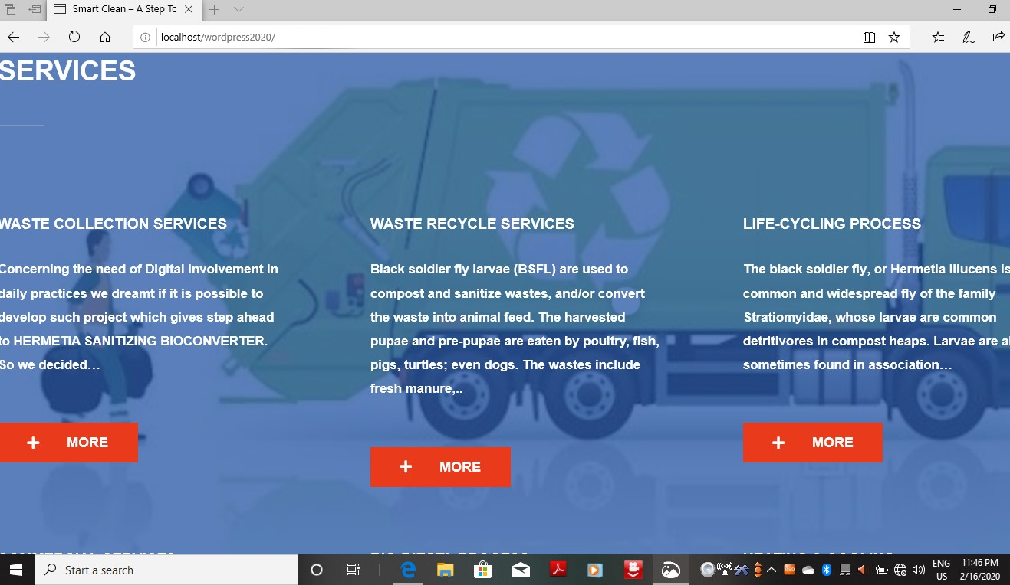**Services page**
8. 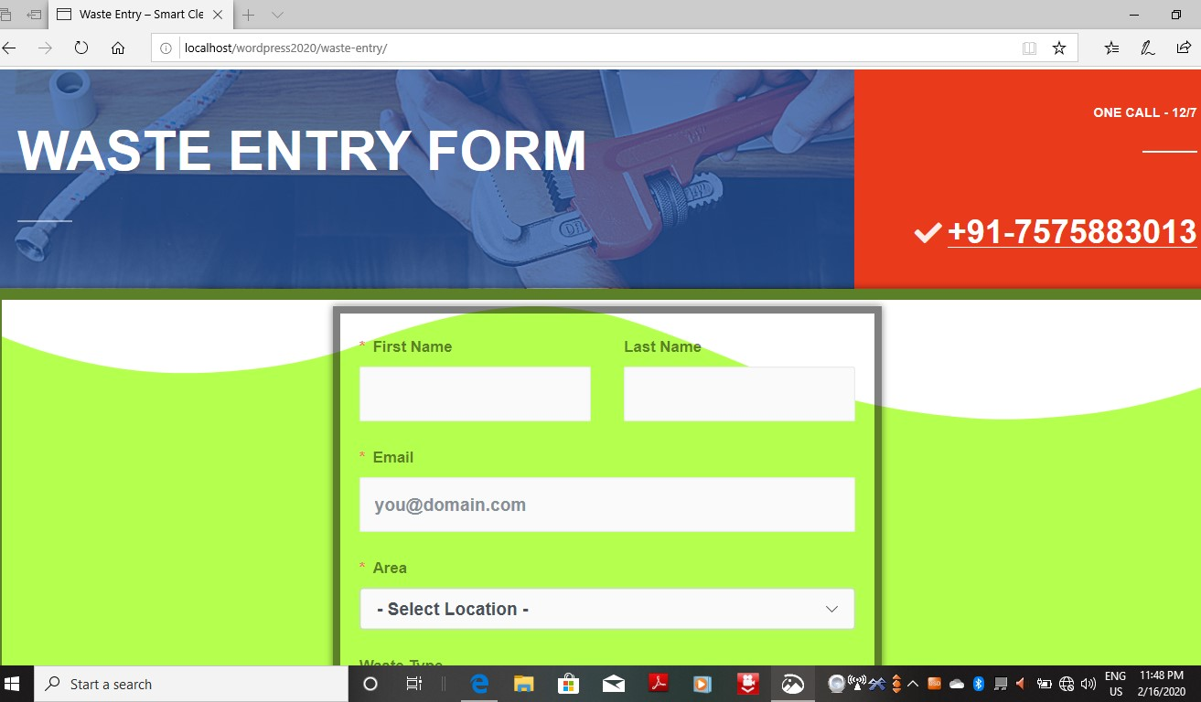**Waste entry form**
9. 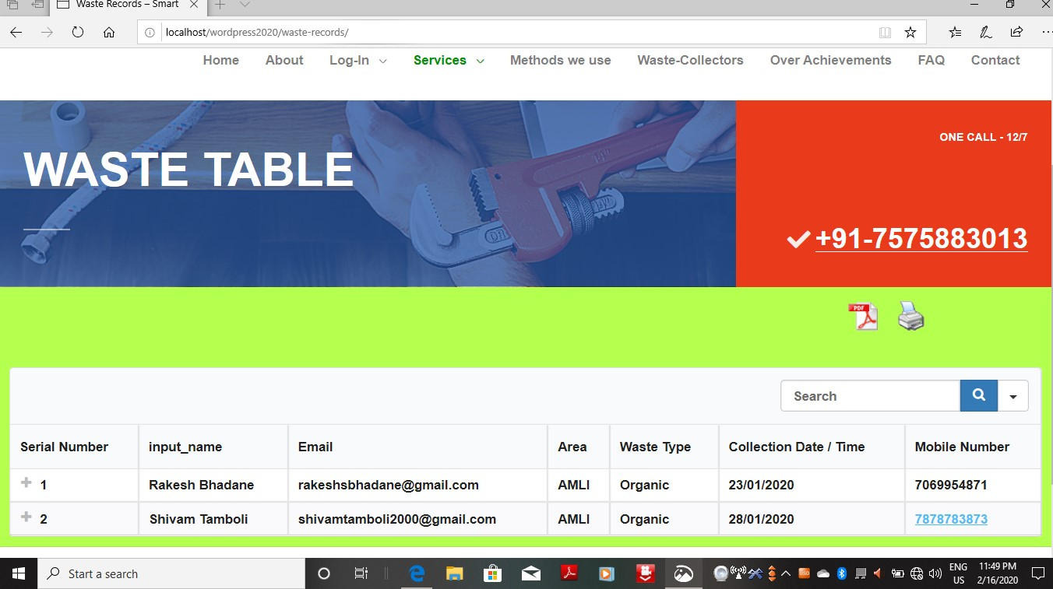**Waste Record table**
10. 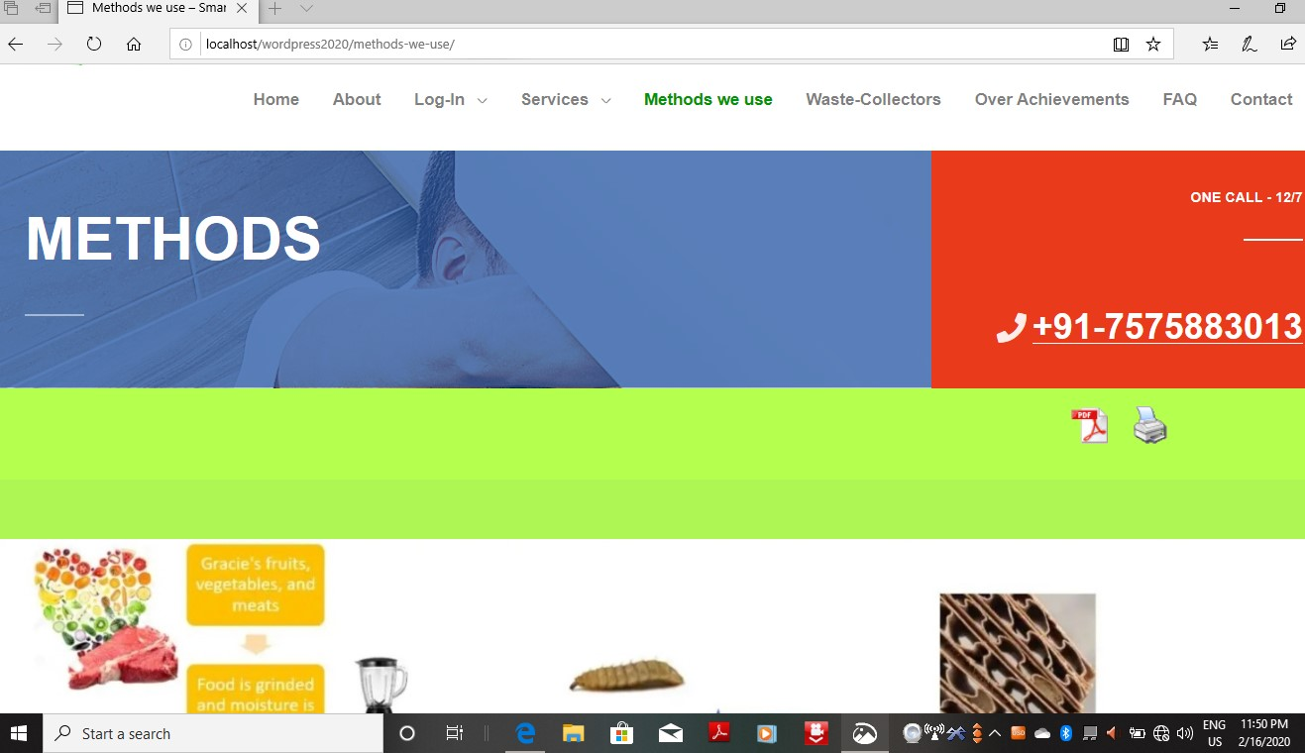**Methods for recycling waste page**
11. 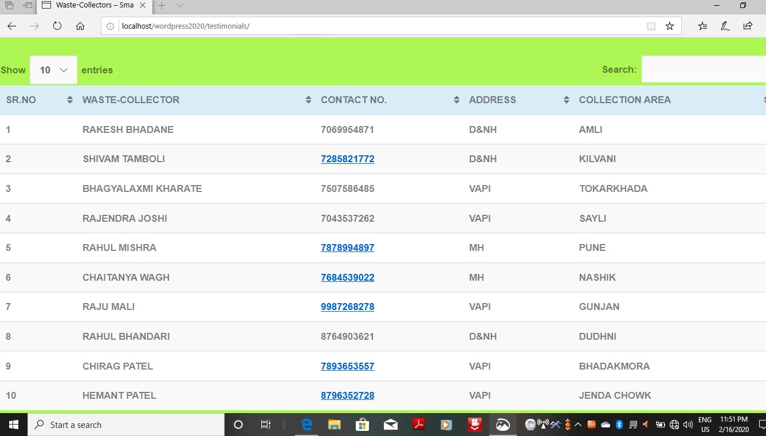**Waste Collectors record table**
12. 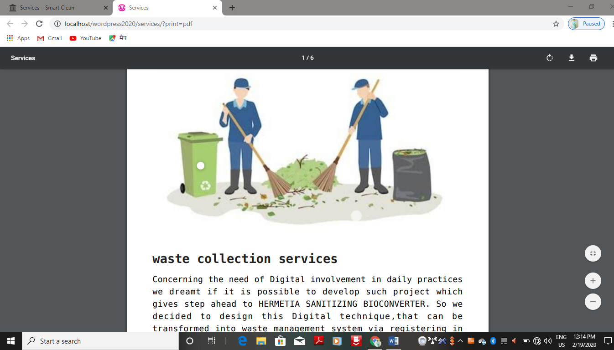**Record Print & PDF option**
13. 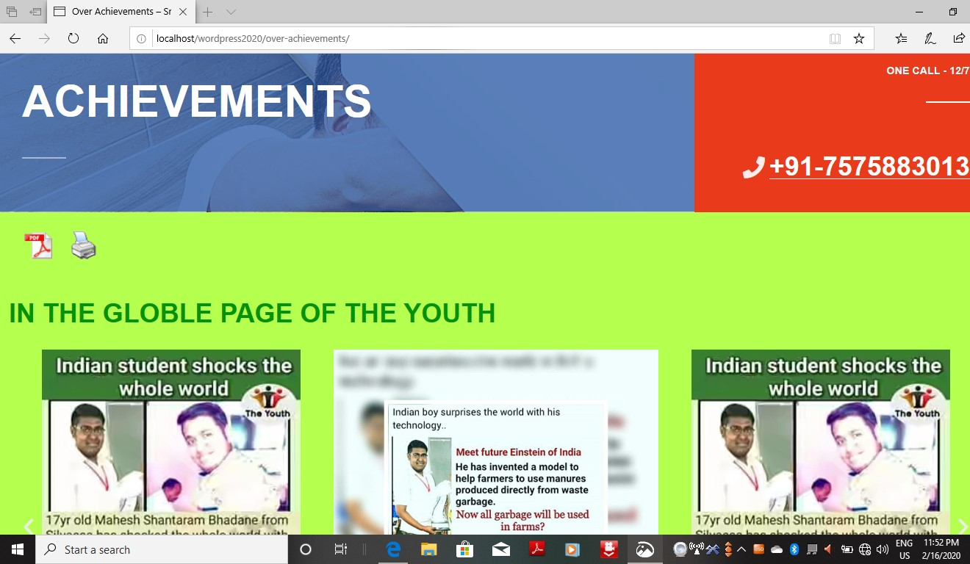**My achievements page**
14. 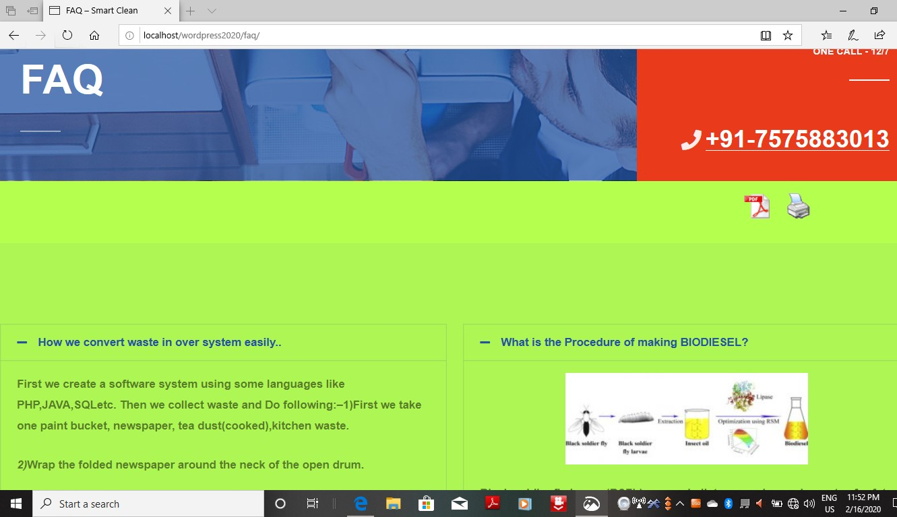**Frequently ask question (FAQ) page**
15. **Contact Form**

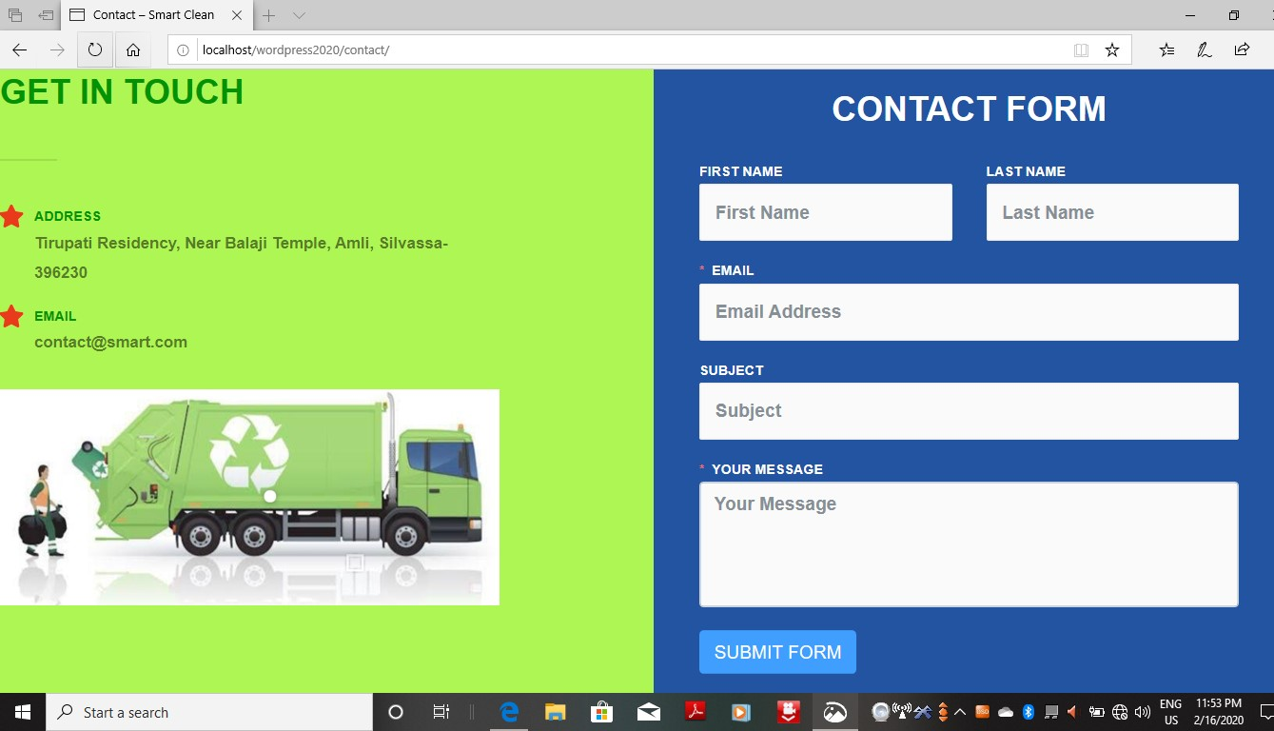

1. **OTHERS**
   1. **DRAWBACKS AND LIMITATIONS OF PROPOSED SYSTEM**
2. Location is manual based not track automatically.
3. Less secure.
4. Limited area covers by the system.
   1. **PROPOSED ENHANCEMENTS**
5. Location tracker which provide direct location.
6. An interface in which user can direct get area wise collector detail only.
7. Cancel Request at any movement will be added.
   1. **CONCLUSION**

The project ‘SMART CLEAN’ was quite a wonderful and learning experience for me.

The proposed project still needs ample of improvements in terms of reliability, security, etc. Still the system will help users to send the request of waste collection to the waste collectors while sitting at home or from anywhere. Further necessary updates will be made in the future.

* 1. **BIBLIOGRAPHY**
* [www.google.com](http://www.google.com)
* [www.wordpress.com](http://www.wordpress.com)
* [www.youtube.com](http://www.youtube.com)
* www.codeproject.com